UC Riverside Spring Classic Invitational
March 24-26, 2016 / UC Riverside Track and Field Complex
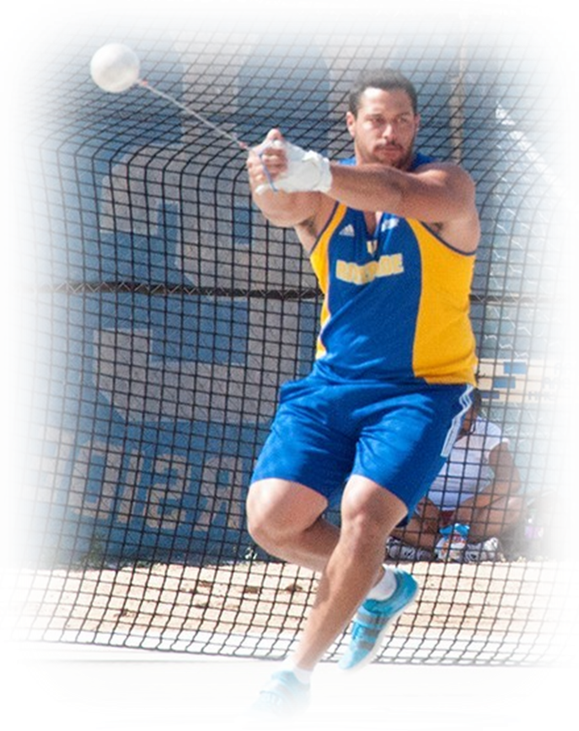
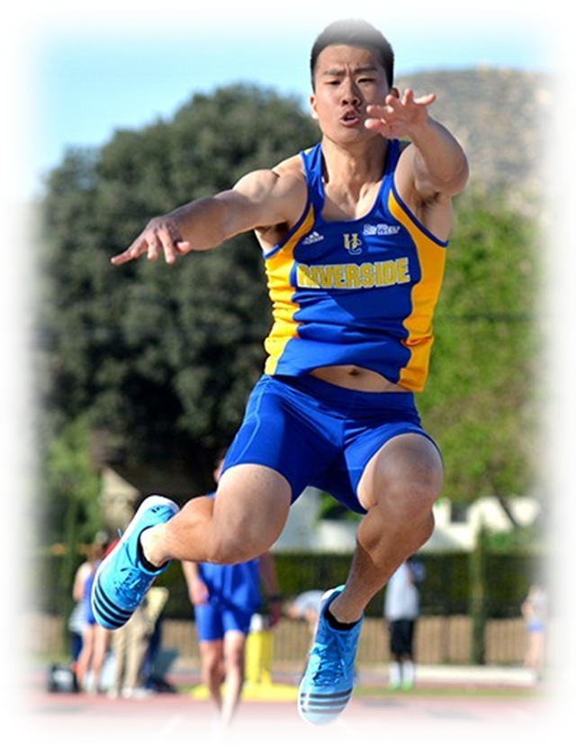
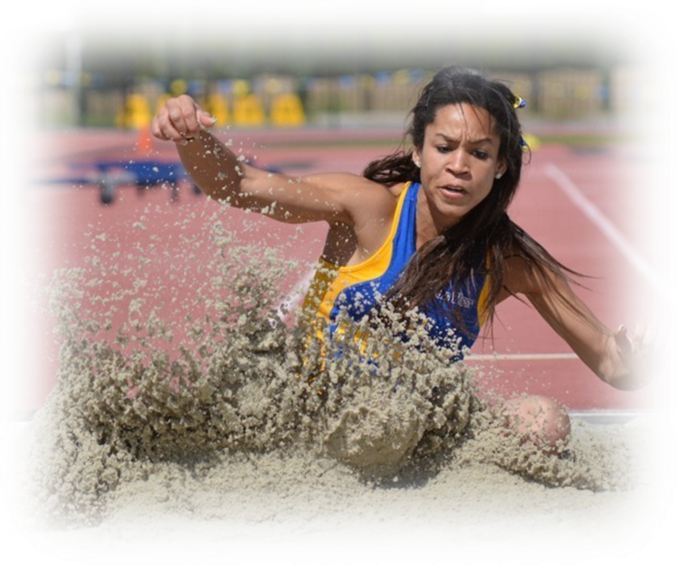


Meet and Entry Information

Daniel Newell I Meet Director I Email: dnewell@ucr.edu

Invited Teams:
Cal State Fullerton, Cal State Northridge, Cornell University, North Dakota State, Northern Colorado, Sacramento State, Southern Utah, UC Irvine, UC Riverside, UNLV, Wyoming
UC Riverside Spring Track Classic

Thursday-Saturday, March 24-26, 2016
UC Riverside Track & Field Stadium - Riverside, CA
*Multi-Event Competition Thursday & Friday *

PRELIMINARY MEET INFORMATION
(Tentative Schedule Included)

The University of California Riverside is pleased to host our 3nd Annual Spring Track Classic. The following bulleted items will answer some general questions.

- Entry Information: The 2016 UCR Spring Classic is by invitation only. No unattached athletes will
be granted entry into Saturday’s competition because this is a team scoring event. Unattached multi-event athletes will be granted entry because the multi-events are not part of the team scores. No ENTRIES/CHANGES will be accepted after the entry deadline.

- Entry Fees/Entry Marks: $500/full team or $250/gender ($20 per individual if not brining a full team).
Make checks payable to UC Regents. An additional $25 will be charged for every multi-event athlete.

- Entry Procedure: ONLY TFRRS marks from 2015-2016 Indoor/Outdoor seasons will be accepted. All entries must be submitted on DirectAthletics. Please submit your entries by Monday, March 21, 2016 at 6:00PM PST. Placement in heats/flights will be at the discretion of the meet management staff. If an athlete does not have a TFRRS mark, they must enter a time that can be verified online.

- TENTATIVE SCHEDULE: Currently, a tentative schedule is available. THIS SCHEDULE IS SUBJECT TO CHANGE and a final schedule will be posted once we have all of the entries and heat sheets are completed.

- Check-in Procedure: Check-in for all running events will take place at the Clerk of Course table located by 100m start area. Check-in at least 45 minutes prior to start of your race and report back to the check-in table 10 minutes prior to your race to be escorted onto the track. Athletes failing to do so may be scratched from competition. Check-in for field events will take place at your field event 30 minutes before competition.

- Timing System: Finished Results (http://www.finishedresults.com) will cover timing and results.

- Scoring/Field Event Info: Scoring will be 10-8-6-5-4-3-2-1. Only three athletes from each team per event can score. In field events, top 9 advance to finals for 3 more attempts.

- Weigh-in of Implements: Throwing implements must be weighed in 1 hour before the start of the Hammer on Friday and between 8:45-10:30am on Saturday at the Track Building, on the south end of the Track Stadium.

- Sports Medicine: UC Riverside Sports Medicine Staff will be set-up and located at the southeast end of the track stadium.

- Warm-up Area/Team Camps: Soccer turf field will be available for warm-up. Team camps can be set up in grass on the outside of the backstretch and second curve along the East and North fences.

- Spectator Info: Ticket prices – Spectators ($5) / UCR Undergrad w/ ID, Ages 3 & below (Free)

- About the Track: UC Riverside's recently renovated track is an 8-lane (9-lane straightaway) Rekortan M99 track surface. There are two adjacent LJ/TJ runways with sand pits at both ends. The discus, shot, and javelin are contested within the track stadium (upper field). Hammer throw is contested on the lower field (located next to soccer field).

• Parking/Directions: Team Bus Drop-off will be on Canyon Crest by Parking Lot #24 (adjacent to track stadium). DO NOT ATTEMPT to park your team bus in lot #24 due to the incline of the entrance. Team Bus Parking will be available in Parking Lot #26 (next to baseball complex). Spectator parking will be available in Parking Lot #24 for $5.00. Directions to Parking Lot #24: From the 215 South / 60 East freeway, take University Ave. Exit. Head east on University Ave. towards campus (University Ave. turns into Canyon Crest). Parking Lot #24 is located on the right immediately after the Softball Field. Parking Lot #26 is located another ½ block down Canyon Crest on the left hand side by the baseball complex.

- Facility Availability and Practice Times: The UC Riverside track facility will be open to teams for workout during the following times/days. During Thursday and Friday there is a Multi-Event competition taking place that will take precedence over any team workout or pre-meet activities on the track or throws areas. Please be respectful of the athletes competing on these days and to be watchful of the infield as the javelin may be taking place. Additionally, due to the multi-event competition and for safety concerns, no discus will be allowed on the upper field until day of competition. Hammer is NOT to be thrown on the upper field at any time and practice for the discus is to take place on the lower field.

- Monday-Tuesday – By appointment ONLY. Please schedule with Daniel Newell if time is needed.
- Wednesday – 12:00pm – 6:00pm (Discus and Hammer available on lower field from 1:00-4:00pm)
- Thursday – 12:00 – 6:00pm (Discus and Hammer available on lower field from 1:00-4:00pm)
- Friday – 12:00-6:00pm (Discus is available to throw on lower field from 11:00-2:00pm)
- Saturday – Competition warm-ups only. (Lower hammer ring is available if needed)

- Spike Pin Type and Size: The only spike pin allowed for our facility is the ¼” pyramid spike. Athletes can be disqualified from the meet if they do not comply with this rule (High Jump and Javelin events are allowed a 3/8” pyramid spike). NO NEEDLE SPIKES OR CHRISTMAS TREE SPIKES ALLOWED (see image below). No permanent spike shoes allowed. Shoes will be checked at last call in the clerk area prior to getting on the track.

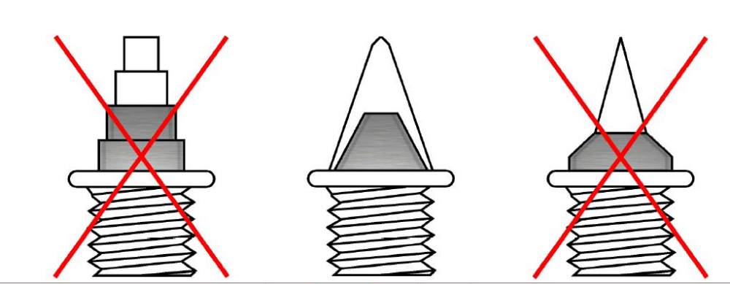

UC RIVERSIDE SPRING TRACK CLASSIC MULTI'S & HAMMER THROW Tentative SCHEDULE
UC RIVERSIDE TRACK AND FIELD STADIUM
Thursday-Friday, March 24-25, 2016
Thursday, March 24, 2016
11:00AM | 100 meters | Decathlon
 | Long Jump | Decathlon
 | Shot Put | Decathlon
 | High Jump | Decathlon
 | 400m | Decathlon
12:00PM | 100m hurdles | Heptathlon
 | High Jump | Heptathlon
 | Shot Put | Heptathlon
 | 200m | Heptathlon
Friday, March 25, 2016
11:00AM | 110 meter hurdles | Decathlon
 | Discus | Decathlon
 | Pole Vault | Decathlon
 | Javelin | Decathlon
 | 1,500 meters | Decathlon
12:00PM | Long Jump | Heptathlon
 | Javelin | Heptathlon
 | 800 meters | Heptathlon
3:00pm | Hammer | Women - Lower Field
To Follow | Hammer | Men - Lower Field

UC RIVERSIDE SPRING TRACK CLASSIC Tentative SCHEDULE
UC RIVERSIDE TRACK AND FIELD STADIUM
Saturday, March 26, 2016
Saturday, March 26, 2016- Field Events
10:00AM | Shot Put | Women
10:00AM | Javelin | Men
10:00AM | Pole Vault | Women
10:30PM | Long Jump | Women – East Pit
10:30PM | Long Jump | Men – West Pit
12:00PM | Javelin | Women
12:00PM | Shot Put | Men
12:00PM | High Jump | Women
12:00PM | Pole Vault | Men
2:00PM | Discus | Women
2:00PM | Triple Jump | Women – East Pit
2:00PM | Triple Jump | Men – West Pit
4:00PM | High Jump | Men
4:00PM | Discus | Men
Saturday, March 26, 2016 - Running Events
12:40PM | Opening Ceremony / Team Introductions
12:55PM | National Anthem
1:00PM | Steeple | Women
1:15PM | Steeple | Men
1:30PM | 400 meter Relay | Women
1:35PM | 400 meter Relay | Men
1:40PM | 1,500 meters | Women
1:55PM | 1,500 meters | Men
2:15PM | 100 meter Hurdles | Women
2:30PM | 110 meter Hurdles | Men
2:45PM | 400 meters | Women
3:00PM | 400 meters | Men
3:15PM | 100 meters | Women
3:25PM | 100 meters | Men
3:35PM | 800 meters | Women
3:50PM | 800 meters | Men
4:10PM | 400 meter Hurdles | Women
4:25PM | 400 meter Hurdles | Men
4:35PM | 200 meters | Women
4:50PM | 200 meters | Men
5:00PM | 3,000 meters | Women
5:25PM | 3,000 meters | Men
5:50PM | 1,600 meter Relay | Women
6:00PM | 1,600 meter Relay | Men

Competition Track, Parking, Throws Areas and Warm-up Field

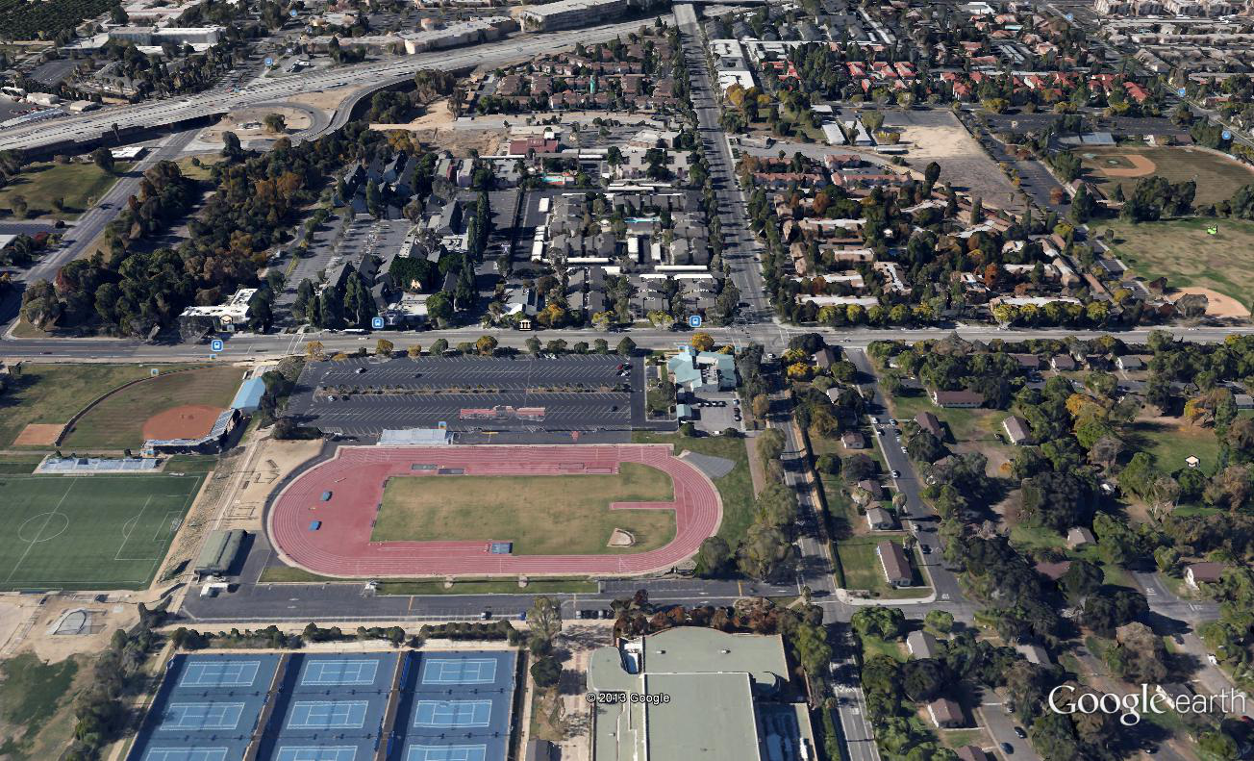
Competition Track
Hammer
Warm-up Field
Parking Lot 24
Parking Lot 26
Highway 60
Canyon Crest
University Avenue
Discus
Shot Put

Preferred Hotel

Marriot Courtyard
1510 University Avenue
Riverside, CA 92507
1-866-576-5620

Additional Lodging

Hyatt Place Riverside Downtown
3500 Market Street
Riverside, CA 92501
Contact: Donna Esparza
951-248-0727
donna.esparza@hyatt.com

Comfort Inn
1590 University Ave.
Riverside, CA, US, 92507
Phone: (951) 683-6000
Fax: (951) 782-8052

Riverside Marriott at the Convention Center
3400 Market St
Riverside, CA 92501
Phone: (951) 784-8000

