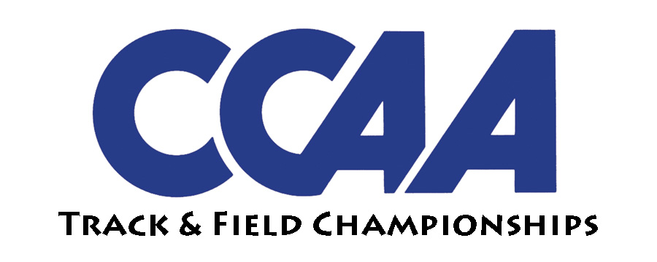

**CCAA MEN’S AND WOMEN’S OUTDOOR TRACK & FIELD CHAMPIONSHIPS**

Al Brenda Track at Warrior Stadium • CSU Stanislaus, Turlock

**2018 Meet Schedule**

**Thursday, May 3**

**8:00 a.m. CSUS Facilities Open**

**9:50 a.m National Anthem**

**10:00 a.m. Decathlon – 100 Meters**

**10:40 a.m. Decathlon – Long Jump**

**11:00 a.m. Heptathlon – 100 Meter Hurdles**

**11:40 a.m. Heptathlon – High Jump**

**11:55 a.m. Decathlon – Shot Put**

**1:15 p.m. Decathlon – High Jump**

**1:25 p.m. Heptathlon – Shot Put**

**2:15 p.m. Heptathlon – 200 Meters**

**3:15 p.m. Decathlon – 400 Meters**

**THURSDAY FIELD EVENTS**

**1:00PM Women’s Hammer(FINALS)**

**3:30PM Men’s Hammer(FINALS)**

**Friday, May 4**

**8:00 a.m. CSUS Facilities Open**

**11:00 a.m. Decathlon – 110 Hurdles**

**11:00 a.m. Heptathlon – Long Jump**

**11:40 a.m. Decathlon – Discus (infield)**

**12:35 p.m. Decathlon – Pole Vault**

**12:30 p.m. Heptathlon – Javelin**

**2:00 p.m. Heptathlon – 800M**

**4:00 p.m. Decathlon – Javelin**

**5:20 p.m. Decathlon – 1500M**

**3:50 p.m. National Anthem**

**4:00 p.m. Women’s 4 x 100M Relay (Prelims)**

**4:15 p.m. Women’s 1500 Meters (Prelim)**

**4:35 p.m. Men’s 1500 Meters (Prelim)**

**4:55 p.m. Women’s 100M Hurdles (Prelim)  
5:15 p.m. Men’s 110M Hurdles (Prelim)**

**5:30 p.m. Women’s 400 Meters (Prelim)**

**5:40 p.m. Men’s 400 Meters (Prelim)**

**5:55 p.m. Women’s 100 Meters (Prelim)**

**6:05 p.m. Men’s 100 Meters (Prelim)**

**6:20 p.m. Women’s 800 Meters (Prelim)**

**6:35 p.m. Men’s 800 Meters (Prelim)**

**6:50 p.m. Women’s 400M Hurdles (Prelim)**

**7:05 p.m. Men’s 400M Hurdles (Prelim)**

**7:25 p.m. Women’s 200 Meters (Prelim)**

**7:35 p.m. Men’s 200 Meters (Prelim)**

**7:50 p.m. Women’s 4 x 400M Relay (Prelim)**

**8:00 p.m. Women’s 10,000 Meters (FINALS)**

**8:45 p.m. Men’s 10,000 Meters (FINALS)**

**FRIDAY FIELD EVENTS**

**1:30 p.m. Women’s Shot (FINALS)**

**4:00 p.m. Men’s Shot (FINALS)**

**2:00 p.m. Men’s Long Jump (FINALS)**

**4:30 p.m. Women’s Long Jump (FINALS)**

**5:00 p.m. Women’s Pole Vault (FINALS)**

**Saturday, May 5 7:00 a.m. CSUS Facilities Open**

**1:20 p.m National Anthem  
1:30 p.m. Women’s 3,000 Steeple (FINAL)  
1:50 p.m. Men’s 3,000 Steeple (FINAL)  
2:05 p.m. Women’s 4 x 100M Relay (FINAL)  
2:15 p.m. Men’s 4 x 100M Relay (FINAL)**

**2:25 p.m. Women’s 1500 Meters (FINAL)  
2:35 p.m. Men’s 1500 Meters (FINAL)**

**2:50 p.m. Women’s 100M Hurdles (FINAL)**

**3:00 p.m. Men’s 110M Hurdles (FINAL)**

**3:10 p.m. Women’s 400 Meters (FINAL)  
3:20 p.m. Men’s 400 Meters (FINAL)**

**3:35 p.m. Women’s 100 Meters (FINAL)  
3:45 p.m. Men’s 100 Meters (FINAL)  
3:55 p.m. Women’s 800 Meters (FINAL)  
4:05 p.m. Men’s 800 Meters (FINAL)  
4:20 p.m. Women’s 400M Hurdles (FINAL)  
4:30 p.m. Men’s 400M Hurdles (FINAL)  
4:45 p.m. Women’s 200 Meters (FINAL)  
4:55 p.m. Men’s 200 Meters (FINAL)  
5:05 p.m. Women’s 5,000 Meters (FINAL)  
5:30 p.m. Men’s 5,000 Meters (FINAL)  
5:50p.m. Women’s 4 x 400M Relay (FINAL)  
6:00 p.m. Men’s 4 x 400M Relay (FINAL)  
6:15 p.m. Awards Ceremony**

**SATURDAY FIELD EVENTS**

**11:00 a.m. Women’s Discus (FINALS) (Infield)**

**12:00 p.m. Men’s Javelin (FINALS)**

**1:30 p.m. Men’s Discus (FINALS) (Infield)**

**12:30 p.m. Men’s High Jump (FINALS)**

**1:30 p.m. Women’s Triple Jump (FINALS)**

**2:30 p.m. Women’s Javelin (FINALS)**

**2:00 p.m. Men’s Pole Vault (FINALS)**

**3:00 p.m. Women’s High Jump (FINALS)**

**4:00 p.m. Men’s Triple Jump (FINALS)**